时间 2022年1月7日星期五

听力生词

Pine park chimneys suffocation hindered medics Necessity stale provision

松园 烟囱 窒息 受阻 医务人员 必要性 陈旧的 条款

slap out promptly Creeks fissures or faults coal-fired power plant Commensurate maternity

拍打 及时的 小溪 裂缝或断层 燃煤电厂 相称的 产妇

Scarce note system marginal cosmetics explode wells implications  hazards

稀缺 笔记系统 边缘 化妆品 爆炸 水井  影响 危害

Stir the interested tuna quite quiet susceptible

(激起兴趣) 金枪鱼 (很) (安静, 比起quite，尾音强调 eeet) 易受影响的 易受感染的

Accommodation self-inflicted Molecular consistent with contamination ingredients

住宿 自作自受 分子 符合 一致 污染 成分

towels surges subsides exotic aromatic wards disinfectant spray vulnerable

毛巾 上升 飙升 激增 消退 减退 异国情调 芳香四溢 病房 消毒剂 喷雾 脆弱的

Pediatrics subtle perceived uneasy inhumane cull instantaneous cope

儿科 微妙 复杂 感知 看作 不安 不自在 不人道 剔除 扑灭 扑杀 a.瞬时的 瞬间的 应对

Adverse art arts Plagiarism stance epicenter debris seismic buoys offshore(离岸) landslide

不利的 美术 文科 抄袭 立场 震中 碎片 杂物 地震的 浮标 近海山体滑坡

Richter scale barrel into barrel

里氏规模 驶入 冲向 n木桶 v.飞奔 高速行驶

阅读生词

semi-arid areas gutters

半干旱地区 排水沟

The biggest problem is the way eating this meat is **perceived**. 最大的问题是人们对吃这种肉的看法。

the Earth’s temperature surges and subsides naturally. 地球的温度自然上升和下降。

Ginger became extremely popular because of its exotic, aromatic properties and was highly valued by spice traders in the 17th and 18th centuries because they were able to sell it back in Europe for a very good price.

由于生姜具有异国情调和芳香的特性，它在17和18世纪受到香料商人的高度重视，因为他们能够以非常好的价格将其卖回欧洲。

And sick people, of course, are very susceptible(易受感染的) to such bugs.

而生病的人，当然很容易受到这种虫子的影响。

These have the standard sink near the entrance door, and also a bottle of disinfectant spray.

这些地方的入口门附近有标准的水槽，也有一瓶消毒剂喷雾。

It is much safer and less likely to explode(爆炸) even when engulfed(被吞没的) in fire.

它更安全，即使被火吞噬也不容易爆炸。

The meat is, by all accounts, **leaner** and **tenderer** than beef. 从各方面来看，这种肉比牛肉**更瘦**，**更嫩**。

And newborn babies are particularly **vulnerable** in this respect. 而新生儿在这方面尤其**脆弱**。

Apart from that, it’s been pretty much plain sailing(一帆风顺) for the hospital, allowing it to gain the high regard(高度评价) in which it is held today. 除此以外，该医院的发展几乎是一帆风顺的，使其获得了今天的高度评价。

It has a strong taste, and minces easily, but it also has some more **subtle** advantages

它的味道很浓，容易剁碎，但它也有一些更微妙的优点

one would think such arguments make the case irrefutable(无可辩驳)

The university takes a tough stance on plagiarism. 大学对剽窃行为采取了严厉的立场。

The Pacific Ocean’s denser oceanic plates are often known to slip under continental plates in a process known as subduction , and subduction earthquakes are the most effective in generating tsunamis.

众所周知，太平洋上密度较大的海洋板块经常在大陆板块下滑动，这一过程被称为俯冲，而俯冲地震是产生海啸的最有效途径。

About 8,000 years ago, a massive undersea landslide off the coast of Norway sent a 30- foot wall of water barreling into the uninhabited northern coast of Europe.

大约8000年前，挪威海岸的一次大规模海底滑坡将一道30英尺长的水墙冲向无人居住的欧洲北部海岸。

注意拼写

Domestic Rubber uncomfortable magazines inconvenient orientation patients London forbidden

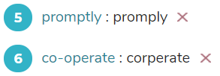不知道没有“-”算不算对

关键词 modern -> today , prospect->aspect , look into -> address, withstand -> prevent … from

Amused -> funny out of here(->leave)

Linking -> attach

Linear notes -> notes in a line

问题**allows** space for other animals(为其他动物提供空间)

听力原文other native animals are **given** space to increase their numbers also

A wealth of -> many

发音：

Drew -> draw

Shells(音80%似 shows), sealed 密封的

Sphere, containing -> spherical container

Shielding 屏蔽

a typed(音或types) cover letter

quote

A of B ，则B为重点。

Question(Q): This coming Saturday, they will go to 

Listening Script(S):

Mary: That’s later in the month. This Saturday we’ll visit Pine Park.

Q: In every meal, there will be ______

S:

Peter: And what about the weekday meals? Salads every night, I suppose?

Mary: No, it’s important to vary the meals so that the food remains interesting and fun. The only common factor is the fruit juice, but otherwise we’ll have a variety of healthy fare, from salads, to fish, to lean meat(瘦肉).

Q: Walls are ___

S: Look around and you’ll see that every room has padded walls.

Padded walls 软垫墙 Padded(音 “趴迪t”)

12 解释

Includes the corners 同义句 this padding extends around all corners

13 解释

**Note:**

From the question, we can assume that the answer must be a noun. The keyword in this question is “teachers”. As mentioned by the speaker, “**our staff are not only trained childcare workers, but all of them have a special skill**”, we can easily conclude that the answer for Q13 is **special skill**. We should notice “**staff”** is equivalent to “**teachers”** in this context.

14 解释

**Note:**

From the question, we can assume that the answer must be a noun. The keyword in this question is “many”. As mentioned by the speaker, “**we have a wealth of learning toys，specially…**”, we can easily conclude that the answer for Q14 is **learning toys**. We should notice “**a wealth of”** has the same meaning as “**many”**.

16解释

**make sure germs are not transmitted**” is similar to “**limit the spread of germs**”.

**Detail Another Detail1**

**Walls are 11 ** **includes the 12 **

**Teachers are able to teach a 13  There are many special 14  They 15  surfaces daily. procedures to limit the spread of 16 **

*Choose the correct letter,****A, B,****or****C****.*

***NB****You may use a letter more than once.*

|  |  |
| --- | --- |
| **A** | Andrea |
| **B** | Bella |
| **C** | Cathy |

Which childcare worker:

**17**  has her own children?

**18**  often sleeps at the center?

**19**  is good with shy children?

**20**  is a good cook?

19解释

The keyword in this question is “good with shy children”. As mentioned by the speaker, “**we let Cathy deal with the particularly quiet and introverted children**”, we can easily conclude the answer for Q19 is **C**. We should notice “quiet and introverted children” is similar to “shy children”

**SECTION 2**

You will hear a childcare worker telling some mothers about the advantages of her centre. Hello everyone, and welcome to the Stanfield Childcare Centre. Now I know you're all new mothers, and you like to cling to your children. You’ve certainly spent a lot of time raising them to the age of four and are perhaps reluctant to leave them here at our centre. Well, one of the first things you should understand is that here it is safe — very safe. Look around and you'll see that every room has padded walls. Other centres have standard painted walls, but here, we have invested a lot to ensure your children will not hurt themselves when running around and possibly tripping over. This padding extends around all corners — that is, the areas most likely to bruise(挫伤) and cut your active little child. So, you can rest assured that any accidents of a physical nature are not likely to happen here.

Now, you don't want to dump your child at this centre and let them waste their lime. You want them to learn, and that’s one of the greatest assets of our establishment. Our staff are not only trained childcare workers, but all of them have a special skill, which they can imparl to your child, whether it be teaching the ABC, some basic mathematics, artistic skills, or physical education. We are particularly known for our pre-school literacy program and have a wealth of learning toys, specially designed to develop your child's potential.

Of course, one concern many mothers have is that, in environments such as these, colds and flus and other viral nasties can be easily spread around. It’s a very legitimate concern, and one which we take seriously, and we pride ourselves on our precautions. For a start, unlike most centres which clean with standard detergents, we disinfect every surface at the end of every day, using a special disinfectant wash. Some places just wipe surfaces daily with a damp cloth, but not us. And that’s just the start. We also physically check your children when they arrive every day, and if we feel your child is sick, we ask him or her to wear a face mask to ensure germs are not transmitted. If your child is noticeably sick, then we ask you to take them back home to recover. This might sound a little unkind, but we hope parents can understand that these measures are for the benefit of all.

Now, at Stanfield Childcare Centre we have excellent childcare officers, and let me briefly introduce them. We have Susan, Andrea, Bella, Cathy, Lisa, and Liz. They’re all fully trained and come with some individual assets which make them even better. Bella, for instance, knows children very well, having worked here for five years, and Cathy has her own family — two little girls — so she can talk to you with first-hand knowledge of what it’s really like to raise children. But getting back to Bella, she often relaxes here after work, spending long hours chatting to parents, as does Cathy in fact. But in terms of hours, nothing can compare to Andrea, who will sometimes spend the night here, staying in our overnight room. Why? Because this centre is very friendly, and simply a great place to be. Bella, for example, used to be quite shy herself but now is marvelous with the little kiddies, as outgoing as any of them. We let Cathy, though, deal with the particularly quiet and introverted children, since having her own family, she knows what can really bring them out.

Of course, what better way to do this than with yummie homemade cakes, and Cathy often gets these from Bella, who can make some of the best in town . Yes, everyone here brings something special, which is why we’re one of the best childcare centres in the business.

22 Focus on ____ area of interest.

**Note:**

From the question, we can assume that the answer must be an adjective. The keywords in this question are “focus” and “

. We should notice “**look more carefully**” is similar to “**focus**”.

23 Write ___ statement.

**Note:**

From the question, we can assume that the answer must be a noun. The keywords in this question are “write” and “statement”. As mentioned by Ms. Harris, “**then just write painlessly, you’ll have to think of a thesis, and this statement could be of several types**”, we can easily conclude that the answer for Q23 is **thesis**.

24 Create ____

**Note:**

From the question, we can assume that the answer must be a noun. The keyword in this question is “create”. As Ms. Harris said to Eirc, “**if your essay is going to be clear, it needs to be logical and organized, and this means you’ll need an outline**”, we can easily conclude that the answer for Q24 is **outline**.

Ms Harris: Then pursue that. However, that alone is far too broad. Break it into various current areas of discussion and relevance, then look more carefully at one of them — say, management and cultural differences, or management and motivation, or other aspects, such as the role of salary, group cohesion, or leadership.

Eric: I would say I’m interested in group cohesion—that is, how people interact in the workplace.

Ms Harris: Well, that’s a start, but you can’t then just write planlessly, without defining exactly what you intend to do within the area you’ve chosen. You’ll have to think of a thesis, and this statement could be of several types.

Eric: Such as what?

Ms Harris: Oh, you could argue a point, something that you believe in; or discuss an issue, looking at its various perspectives; or critique the opinions of others, pointing out the pitfalls and flaws. The thesis statement will make that very clear because it will say, in simple terms, what you intend to achieve in your essay.

Eric: I see. And then I can just begin writing, right?

Ms Harris: Wrong! [Uh?] If your essay is going to be clear, it needs to be logical and organised, and this means you’ll need an outline. This could be written as a flowchart, or spider graph — that is, a series of connected lines, but whatever shape the outline takes, there must be a sense of progress, in, more or less, a straight line, towards a goal.

Ensure ___ clearly

**Note:**

From the question, we can assume that the answer must be a noun. The keyword in this question is “create”. As Ms. Harris said to Eirc, “**there must be a sense of progress towards a goal**”, we can easily conclude that the answer for Q25 is **progress**. We should notice “**a sense of progress(进步感)**” is equivalent to “**clear progress（明显进展）**” in this context.

The formatting must followed the 29.____ issued by the university as well as the words count decided by the lecturer, also it can vary by 30.___

**29 Note:**

From the question, we can assume that the answer must be a noun. The keywords in this question are “format” and “follow”. When Ms. Harris said to Eric “**ensure that you format it clearly**”, we can know that the relevant information will soon appear. As stated by Ms. Harris, “**I mean the practical considerations, as written in the university style guide**”, we can easily conclude that the answer for Q29 is **style guide**.

**Note:**

From the question, we can assume that the answer must be a number. The keywords in this question are “word” and “vary”. As stated by Ms. Harris, “**your individual lecturers will give you a word-count figure, so follow what they say, making your essay neither too long, nor too short—perhaps 10% either way should be acceptable**”, we can easily conclude that the answer for Q30 is **10%**. We should notice “**10% either way should be acceptable**” is similar to “**it can vary by 10%**”.

39． Modern geocentrism (is) based on the ___ .

**Note:**

From the question, we can assume that the answer must be a noun. The keywords in this question are “modern geocentrism” and “based on”. As mentioned by the speaker, “**modern geocentrism is usually the result of literal interpretations of the Bible**”, we can infer that modern geocentrism based on Bible. Therefore, the answer for Q39 is **Bible**.

Modern geocentrism is usually the result of literal interpretations of the Bible, which is the cornerstone(基石) of these people's beliefs.

现代地心说通常是对圣经字面解释的结果，这是这些人信仰的基石。

2022年1月7日星期五 08点47分 早期三亮

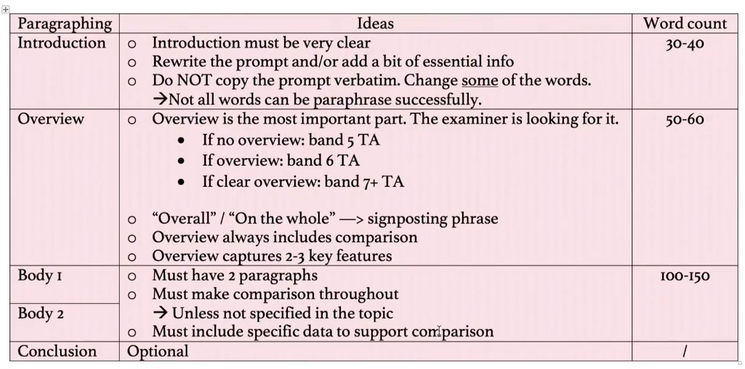

[IELTS Recent Mock Tests Volume 6 Listening Practice Test 4 (ieltsonlinetests.com)](https://ieltsonlinetests.com/ielts-recent-mock-tests-volume-6-listening-practice-test-4)

雅思听力 开始 14点50分 2022年1月7日星期五

100 to 200 **31**  pass through our bodies every second. 答案是billion无s

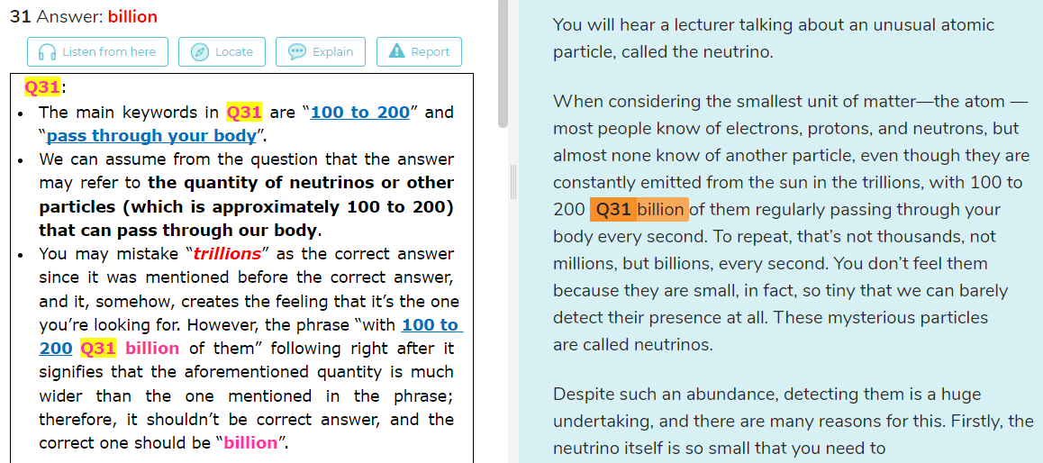

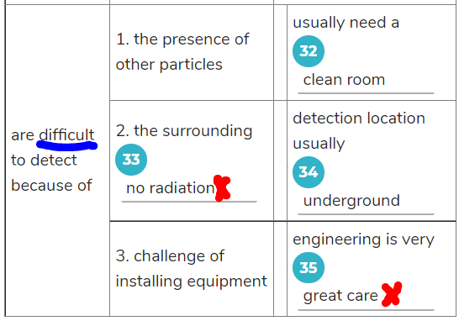

33 因为有difficult， 所以不用加no 下次审题的间隙时间要抓紧

Q 35

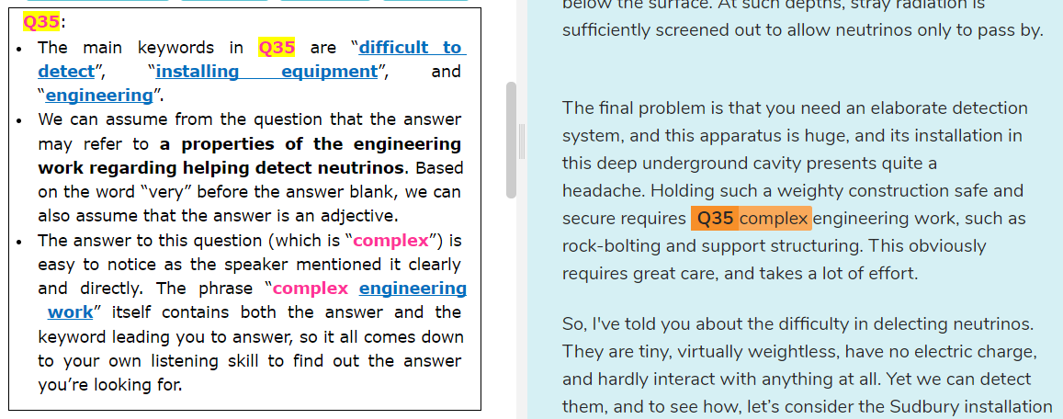

### Questions 21-24 10个里面错了6个，听力稿要听五遍。

# SECTION 3

Dylan: Hi, Emily. What did you think of that lecture?

Emily: A bit hard to follow, but I have some good lecture-listening note-taking strategies which really help, so I can review the lecturer’s message later.

Dylan: Lecture-listening note-taking strategies? Review it later? That sounds interesting. I must admit, I struggle a bit to take down the gist of what I hear. Look at my notes.

Emily: Well, I can see a basic problem immediately. You’re writing full words, such as  ‘century’ when all you need is a ‘C’, And don’t write ‘increase’; just draw an ‘up’ arrow. And why write ‘thousand’ when a ‘th’ will do?

Dylan: I see. Just use symbols. That’s not a bad idea at all.

Emily: It’s the most basic strategy, allowing you to record information at a faster pace. These lecturers can talk faster than others, too, so you don’t want to waste any time. But you need to be very familiar with your set of symbols.

Dylan: Why?

Emily: Because you’ll have to look at these notes days, weeks, or even months afterwards, when you begin writing your essay, so you’ll need to be able to interpret them at a later stage.

Dylan: I think I can do this, even by looking at your notes. ‘Immed’ must mean immediately.

Emily: But regarding the lecture as a whole, I knew the professor would be giving a set of specific recommendations, and comparing two alternative approaches, so I formatted my page in advance, adding the features consistent with the nature of what I was going to hear.

Dylan: Ah ... I think I need an example of what you mean.

Emily: Well, look at my page. Before the lecture, I drew large headings saying ‘recommendations’. You should always draw these, and I drew a table saying, ‘Approach 1’ and ‘Approach 2’. At the end I drew a flowchart, as obviously the final recommendation would be a step-by-step approach. Then I was prepared in advance to simply fill in the spaces.

Dylan: Wow! Now that’s clever.

Dylan: Your advice about note taking sounds great, but I still have one question, Emily. How are you able to design your page in advance? I mean, how can you predict the nature of the talk, and know which design is likely to work best?

Emily: It’s rather obvious when you think about it. What’s your next lecture about?

Dylan: Legal Studies.

Emily: Well, that suggests to me that you’ll need a flowchart, since the judicial system has a very logical ‘do this first, do that second’ approach, which must be followed in that order—y’know, all the processes that happen in the courtroom, and the procedures that must take place to ensure complete legality.

Dylan: Sure. That’s the way law is, very linear and orderly, but what about Culture Studies? That’s just a mass of comparisons of different cultures.

Emily: Which tells you that you will need a table, where, in tabular form, you can efficiently write down information.

Dylan: But often the lecture’s not that simple. The professor throws in a really complex mix of ideas.

Emily: Then use a spider graph—like the web a spider makes, where there’s a central idea around which you attach all the associated thoughts, and ideas, and impressions.

Dylan: I see. I think I understand. And that would be very quick, too; very efficient. I like that. But what about Management Theory? How would you approach that?

Emily: The same as with Culture Studies. I’d use a network, which is basically the same as a spider graph, linking thoughts, although this time there are directions involved. It is this element that makes it different—the fact that the thoughts go one way and not the other.

Dylan: Okay ... has directions. It sounds logical. And what about the other subjects, such as Political Science? There’s no predictable order to that.

Emily: Well, for that I’d just put my notes in a line, that is, in linear, or straight-line fashion, and these notes would use symbols, of course, to save time.

Dylan: Okay, that just leaves Mass Media.

Emily: For that, I wouldn’t have any special design at all. As you say, sometimes it’s impossible to predict in what way lecturers will present their information, in which case the best you can do is pre-write headings, but not specific, just general, as in Main One, Main Two, Sub One, Two, and Three, and so on.

Dylan: Okay.

Emily: But always be prepared to adapt to the nature of the talk, using any one of the other methods if it becomes appropriate at the time.

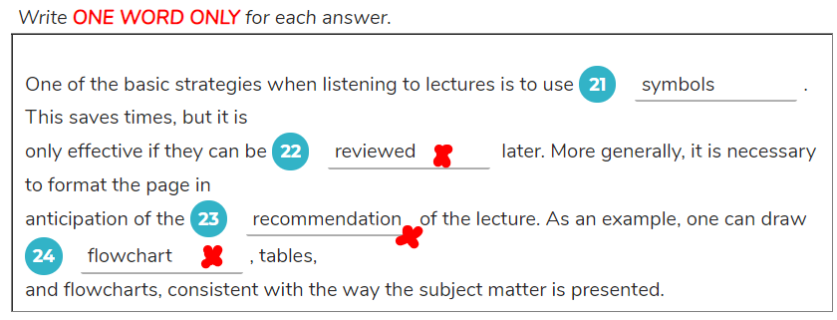

22. can be xxx -> need to be able to xxx

later-> at a later stage

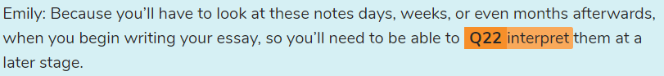

**Q23**:

* The main keywords in **Q23** are “**format the page**” “**in anticipation of**” and “**lecture**”.
* We can assume from the question that the answer may refer to **something related to the lecture that should be based on when formatting the page**.
* There Are two kinds of thing mentioned in the talk, one of which can be considered to be the correct answer: “***features***” and “**nature**”.
* The girl mentioned that the ***features*** should be **consistent with** the **nature** of **what I was going to hear**, proving that the ***features*** need to base on the **nature** in order to be suitable to the **lecture** (the phrase “**what I was going to hear**” refers to the **lecture** itself). Therefore, “**nature**” should be the correct answer to this question.

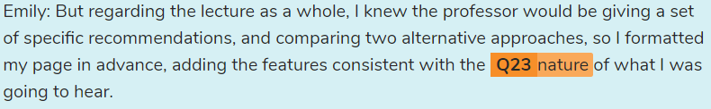

anticipation of the xxx-> 预测 遇见 xxx-> adding the features consistent with the nature of **what I was going to hear**

**Q24**:

* The main keywords in **Q24** are “**example**”, “**tables**”, and “**flowcharts**”.
* We can assume from the question that the answer may refer to **an example regarding the aforementioned page-formatting which is mentioned firstly (before tables and flowcharts)**.
* You can see that the question is a list of things can be drawn based on the aforementioned act of formatting pages. Therefore, you should focus on what is mentioned firstly before the girl mentioned **tables** (as the answer blank is placed before it).
* The answer for this question (which is “**headings**”) is easy to notice as it was said clearly and directly. The girl mentioned everything in the exact order in the summary, so it’s shouldn’t pose too much of a challenge unless you don’t pay attention to the talk.

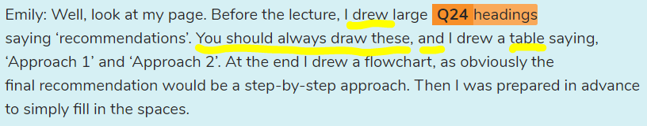

Heading is end with drew, so the answer is not recommendations

Headings is before table while flowchart is after, so the answer is not flowchart

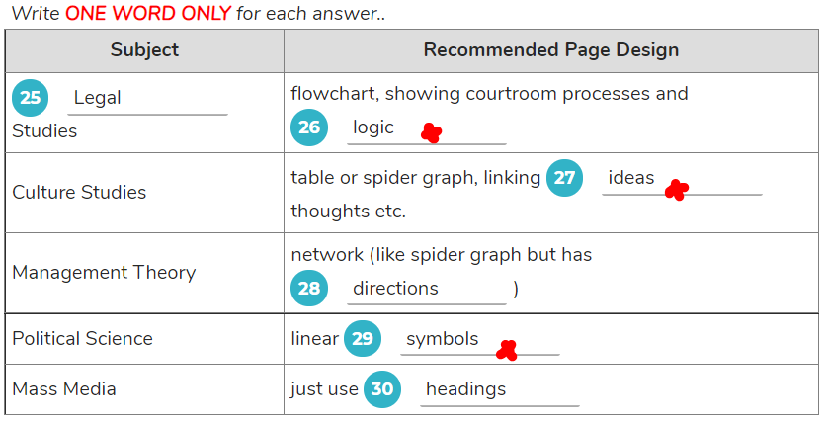

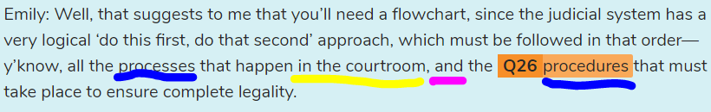

judicial system 司法系统

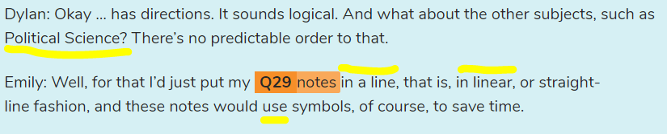

**Q29**:

* The main keywords in **Q29** are “**Political Science**” and “**linear**”.
* We can assume from the question that the answer may refer to **something regarding Political Science that should be placed in line**.
* The answer to this question (which is “**notes**”) is noticeable as it was mentioned clearly and right from the start. Phrases like “**in a line**” and “**in linear**” following after it strengthen the fact that it is the correct answer.
* In some circumstances, you may mistake “***symbols***” as the correct answer because it was also mentioned by the girl (“***these notes would use symbols***”). Note that the girl said that ***symbols*** can be used in **notes**, pointing out that it’s inferior to **notes**, or rather, an incorrect answer.

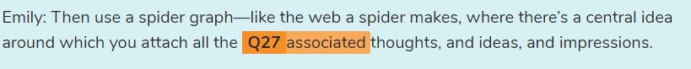

Q27 thoughts 音“朵ts”

(Culture Studies) table or spider graph, linking **27**  thoughts etc.

到17点08分，还差两个部分没有订正完成。

# SECTION 2 (10个错5)

You will hear the director of a language-centre library explaining about its facilities to some new students.

Welcome to the library, or the I.L.C.. which means Independent Learning Centre, and let me explain about some of its facilities. We're standing here at the entry gales, next to the borrowing desk. That's where you check out any books, but you are also advised to study in the library here, since most of our material cannot be borrowed. Thus, we have Seating along the middle of the library, and in that far corner in front of us. on the left, we have the Quiet Reading Section, for some serious reading activity.

We used to have the computers there but then realised that that corner was very quiet, and thus better suited for the purpose it now has. The computers were instead shifled to a more central location, right beside us here, on the left. Again, somewhat confusingly, this area once housed the Newspaper and Magazine Section, but the people in the Quiet Reading Area had to walk loo far to collect this literature, so it was moved to right beside them, in the adjacent corner. So, feel free to read the newspapers there. But the reference books, those huge weighty dictionaries, atlases, and encyclopedias, were all situated at the opposite end of the building, against the wall. This was because they weren't generally that popular, and we wanted more space for the magazine racks, always a favourite with readers.

Okay, as well as reading, you need to work on your listening skills, and for that you need the Audio Section. Again, such an activity needs a quiet area, so we put this in the last remaining corner, up there on your right, as you can see. There are CD players and headphones, so just borrow the listening packs, sit down there, and listen away.

Right, that just leaves the main library. In other libraries, that's often right beside the Newspaper and Magazine Section, allowing freedom to choose from all genres of literature, but here, we've got them further apart. For the main library, just follow your nose(正前方), past the central settling there, and it’s there among all that shelving(货架), upon which you’ll find an abundance of interesting hooks and listening packs to use.

Now, I’d like to tell you a bit more about an excellent service offered in the I.L.C. here that we call the 'Special Sessions'. What can you do in them? For a start, many of you need practice in speaking English. and for that we hold a special Discussion Session, led by a teacher. That can be noisy, in fact, we hope that it is noisy, since that would mean many people are talking. It's in the Central Seating area, and it used to be from 10.30 to 1.30. but we found that the noise was disturbing the regular I.L.C patrons, so we shortened and moved this discussion to the morning, 9.00 am time slot, when fewer people tire in the centre. It goes for one and a half hours.

Alright, what about Writing Skills? Well, we can help you there with another teacher. Now, writing is a fairly quiet activity, so that teacher stations him or herself in the Quiet Reading area from 1.30 until three. The 10.30-to-midday time slot cannot have a teacher for such writing skills, as they are all teaching in the morning. For this reason, of course, there cannot be an on-call teacher in the morning either, although many people would like one, particularly the 10.30-to-noon crowd, having just finished their early morning  
class. These students all have to wait until midday onwards, when, for three hours, a teacher will be stationed in the Audio Section, ready to deal with all those questions.

Until recently, we had another teacher doing the 3-pm-to-6-pm time slot, in the Central Settling, but all the noise interfered with the late users of the I.L.C., so we had to cancel that. Also noisy can be the Language Exchange, where local students who want to learn your language will help you practise English. This is generally done in pairs, so the noise level is low enough not to need this exchange lo run at 9 am, but at a more congenial time of 10.30, among the Central Seating. That must finish by 1.30 though, tiller which quieter and more individual activities take place.

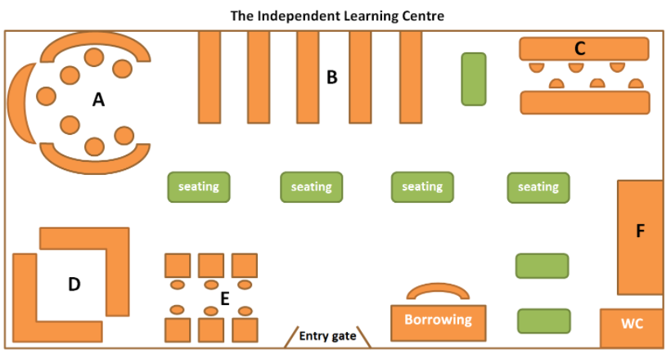

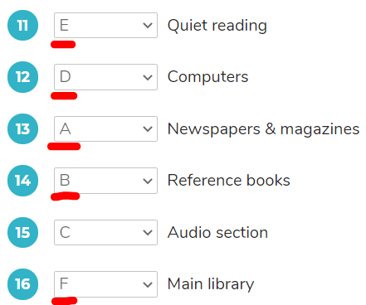

Q12. The full phrase should be “***a more central location***, **right beside us here, on the left**”, which shows that the computers is right next to the current position on the left, which is **E**. As a result, **E** is the correct answer in this case.

**it is right(正好) beside us on the left(它就在我们的左手边)**

Q15. Up there on your right(在右上方)

Q16. 见录音稿

Married, no children 注意逗号，然而没逗号也算对

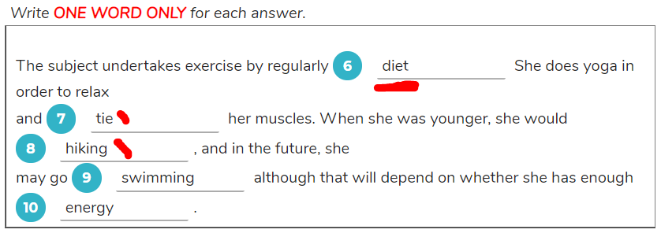

**Q6**:

* The main keywords in **Q6** are “**exercise**” and “**regularly**”.
* We can assume from the question that the answer may refer to **a type of exercise that the person does mostly**.
* The person mentioned two types of exercise, ***cleaning*** and **walking**. However, ***cleaning*** is what her husband does, as she said, so you should choose **walking** as your correct answer since she said that she did that **very often** (the phrase “**very often**” is similar to the keyword “**regularly**” in meaning).
* Remember to use the correct form of verb because the person didn’t say “**walking**”, but using the infinitive form of the answer (“**walk**”). Writing “walk” to your answer sheet may cause your answer to be unaccepted.

**Q7**:

* The main keywords in **Q7** are “**yoga**” and “**muscles**”.
* We can assume from the question that the answer may refer to **a benefit regarding muscles when that person does yoga**.
* The answer (which is “**tighten**”) is quite noticeable as that person said it directly and clearly. Note that the summary has already mentioned that the person does yoga in order to relax, so you shouldn’t write down that word to your answer sheet. Otherwise, you’ll lose an easy point.

Tighten 没听清

Q8. I used to hike in a nearby national park. (Hike in not hiking)

Rep.: Well, the main question is in what form you take your exercise, however little that may be — for example, in just cleaning. Do you clean the house?

Person: My husband does the cleaning, actually, but I walk to the supermarket and shops very often, up to four times a week.

Rep.: I’ll put that then, unless there’s something else.

Person: Nothing else, really. But I diet. I’m very strict about what I eat. Oh, and I do yoga, although that’s not very energetic—more a form of relaxation, and to tighten my muscles.

Rep.: They’re both important, of course, but what about sport? Do you undertake any sporting activities? This could be very infrequent. In the past, for example.

Person: My husband plays basketball at the local school, and I sometimes watch. When he was younger he was in a basketball team, but I never participated.

Rep.: Have you done anything at all?

Person: I used to hike in a nearby national park.

Rep.: Well that’s a definite physical activity, so I’ll put that—but not basketball. Alright, that just leaves future exercise intentions. Do you plan, or expect to do, at some stage, any form of exercise?

Person: I once dreamt of doing modern dance, but that’s never going to happen. Realistically, I’m thinking about going swimming, at the local aquatic centre, although my husband thinks we should just jog. I can’t see myself doing that, though—too tiring.

Rep.: I can understand. I used to jog, too, and it really makes you sweat. I’d say swimming’s a much better option.

Person: But I’ll be starting this job as a cook in my husband’s restaurant. I imagine I’ll be very tired doing all those late shifts. But if I have any energy left over, I might go to the aquatic centre to release some stress.

Rep.: Alright. Well, that’s the end of the survey. Thank you very much for your time.

15点07分 2022年1月8日星期六

# SECTION 4 (10错6)

You will hear a lecturer discussing techniques for removing carbon dioxide from the atmosphere.

We all know about the role of carbon dioxide in causing global warming. Obviously, society needs to reduce the release of carbon dioxide, otherwise known as CO2. This gas comes from the burning of fossil fuels, such as coal and oil. and it is virtually impossible for society to prevent, or even limit such activity. Our need for energy and power is just too great. Instead, a more practical idea is to collect the carbon dioxide from the burning process, for example, directly from the chimneys of power stations, and somehow prevent this gas from being released into the environment. To do that, you need to store it somehow, and that has to be essentially forever.

It is perhaps for this reason that main believe that, rather than storing the carbon dioxide as a gas, it is better to react it with metal oxides, such as magnesium or calcium, which results in the formation of a hard carbonate material. The gas is, in effect, turned into a stable and unreactive solid, which can simply he dumped anywhere. This process actually occurs naturally, although very very slowly, and is one cause of the surface limestone in the world. But this slow reaction speed is the problem. Even when enhancing this process through high temperature and pressure, or pre-treatment of the mineral, it is still far too slow to be economical.

One other technique which has been suggested is to pump the gas lo the bottom of the ocean, where it would react with compounds in the seawater, forming carbonic acid. However, this alternative has now been ruled out. The CO2 may be removed from the atmosphere, but the high oceanic acidity which would result raises its own set of problems, mostly with all the delicate life and the intricate food chains in the seawater, some on which we ourselves depend -- and that's something which no one wants to experiment with.

Perhaps because of the lack of alternatives, the most commonly discussed solution to the problem of disposing of carbon dioxide is to pump the gas underground - a technique known as ‘geosequestration’. In this system, the CO2, for example, could be pumped into underground pockets within depleted oil wells, or disused coal tunnels. This carries, however, three serious disadvantages, namely: the risk of leaks, the considerable costs involved, and finally, the unproven effectiveness. Let us look at those three disadvantages in detail.

Firstly, there is the risk of leaks. Although the gas would be deep and sealed over by masses of rock and earth, the huge pressures in these spaces would turn the gas into a liquid stale, capable of moving through rock fissures or faults. This could allow the gas to eventually be released to the surface. Since CO2 is heavier than air, and thus pushes oxygen aside, such leaks could result in the suffocation of thousands, or tens of thousands of people — certainly not a consequence to be taken lightly. Natural CO2 leakage from volcanic build-up has already witnessed such deadly events.

The other problem of geosequestration is the cost. The time and effort spent on materials and construction, primarily the pipework(管道工程 管线) through which the gas would travel, does not come cheaply. So, if this system were to be implemented in, say, coal-fired power plants(燃煤电厂), the extra cost would have to be paid by the electricity user, whose bills would almost double as a consequence. Few people are prepared to pay this much simply to make a small dent on the effects of global warming. And this leads to the final problem.

The most basic question is whether geosequestration(地质封存) actually reduces global warming. The problem here is that the energy needed to create and drive the sequestration(封存 隔离) process would require approximately a quarter of a coal-fired electricity plant's output. In other words, the plant would have to burn one quarter more of its coal just to account for the sequestration of the carbon dioxide, and with coal producing other noxious pollutants, such as sulphur, ash, and heavy metals, the environment is hardly benefited at all. Nevertheless, there are many active experimental efforts underway, primarily in oil production sites. These are small but intensively monitored and analysed. All we can say now is that the jury is still out on whether underground carbon storage will one day be feasible.

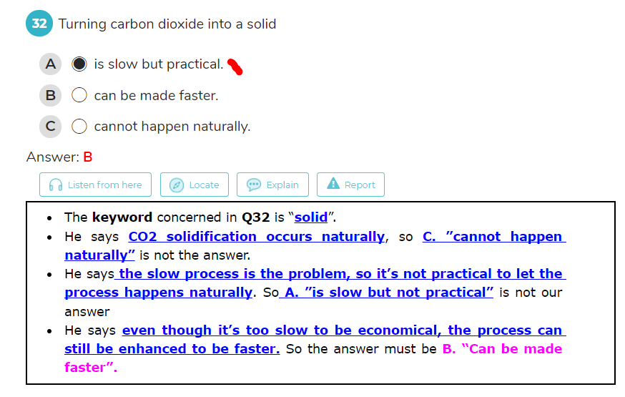

It is perhaps for this reason that main believe that, rather than storing the carbon dioxide as a gas, it is better to react it with metal oxides, such as magnesium or calcium, which results in the formation of a hard carbonate material. The gas is, in effect, turned into a stable and unreactive solid, which can simply he dumped anywhere. **This process actually occurs naturally**, although very very slowly, and is one cause of the surface limestone in the world. **But this slow reaction speed is the problem.** Even when enhancing this process through high temperature and pressure, or pre-treatment of the mineral, it is still far too slow to be economical

C said cannot happened naturally,所以C错了

A said slow but practical(缓慢而实用) 所以A错了

Q 35 关键词 become(问题) -> turn into(原文)

Q 36 关键词 particularly -> primarily(主要是)

Expensive -> does not come cheaply

Q 38 关键词widespread(普遍的 广泛的)

Q 39 关键词price -> bill

Q 26 double-sided -> both sides

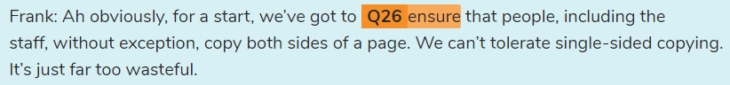

# SECTION 2 (全军覆没)

You will hear a first-aid officer talking to a group of factory workers about emergency first aid.

Hello, everyone. Now, you know why I'm here. You all work in a factory, and in this environment, there always remains a significant possibility of accidents happening, in which case, first aid will be necessary. What is first aid? It is the provision of emergency on-site care when an injury occurs, and it is essential for everyone to know, if only simply, the steps which must be followed.

There are, of course, minor injuries which may happen, not needing further medical care beyond the intervention of the first-aider, but you can never be sure, thus the following steps must always he followed. These can be abbreviated to the words. 'Dr ABC"— in other words. D — R— A —B—C . The 'D' stands for "danger", and that's the first issue to keep in mind. When an accident happens, immediately ascertain that the environment is safe — that, for example, nothing else will fall or break or cause accidents. If you, the first-aider, are also injured, the problem is even worse. The 'R' stands for "respond'. You must then ascertain the best response. Once all the danger has been eliminated, and the distress calls sent out, the appropriate action is, obviously, to help the injured parly.

Alright, that leads to 'A', which stands for "airway". In order to stay alive, all people need to have an open airway to allow breathing. A conscious person will automatically clear their own airway, but if unconscious, this may not happen. The brain is stopped or hindered from properly directing the body and, obviously, in the worst case, death can result, for this reason, the injured person is normally put into the 'recovery' position — placed on the side, tilling the head back(把头往后翻), and ensuring that there are no blockages in the mouth. To free any such blockages, the back can be slapped, or the chest compressed, allowing anything to be spat out. Now that the airway is free, cheek for 'B' or 'breathing'. If breathing is not happening, or is irregular, the fust-aider may have to assist with what is technically known as cardiopulmonary resuscitation, or more commonly. C P R. This involves breathing for the patient, through mouth-to-mouth contact, while periodically massaging the heart through compressions to the chest. This combination allows blood, and oxygen, to flow around the body, keeping the patient alive, hopefully until medics, such as doctors, advanced first-aiders, or ambulance staff, arrive.

Now, it’s certainly good to have know ledge of emergency fust aid. but. obviously, the best situation is simply not to have accidents occur in the first place, for that, you need to be aware of safety issues, but just saying "be aware' does not usually achieve much. It is more important to have an appointed person whose job is to ensure awareness and work- safety. Safely inspections would obviously be part of their job, whereby'they can make sure, for example, that the first-aid boxes are fully equipped. Another idea is to put posters on the walls, but. interestingly, research has proven that these lend to he ignored, becoming just part of the wallpaper—seen, but not put into practice. It is much better if everyone is just instilled to not be reckless, that is,to not rush into situations without thinking about the possibility of accidents, and instilling this mindset is part of the job of the safety officer. Some other suggestions are ongoing first-aid training, and ‘no accident’ reward or star systems. These have had some success, but nothing beats a regular meeting, say , once a month, in which the subject of safety is brought to the attention of everyone, and any outstanding issues related to this are thoroughly discussed.

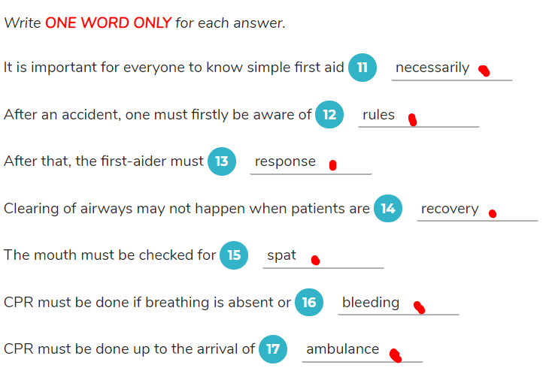

Q11. Important->essential

Q13. Response n. Respond v.

And it is essential for everyone to know, if only simply, the steps which must be followed.

 Q 12

Q15 must be checked -> ensure

Q16 absent -> not happening

* The **keyword** concerned in **Q16** is “**breathing**”.
* From the question, we can presume that the answer must be an adjective.
* “**Not happening**” is equal to “**absent**”.
* She says **if breathing is absent or irregular, the CPR must be done**. So the answer must be **irregular**.

Q18. Have a safety officer ->Appointed person whose job … work-safety

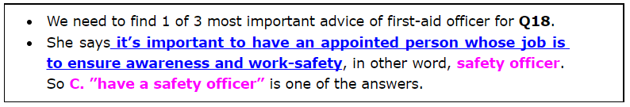

阅读

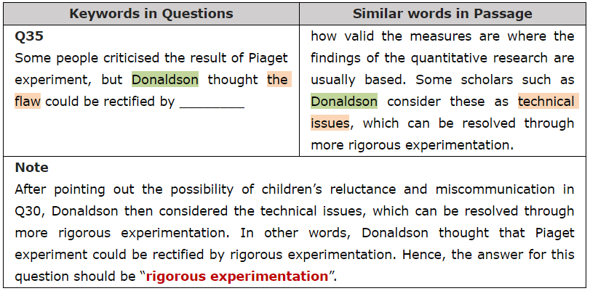

Rectified -> resolved

Rigorous 严格的

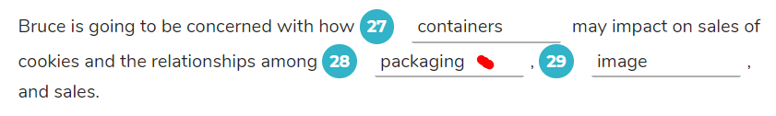

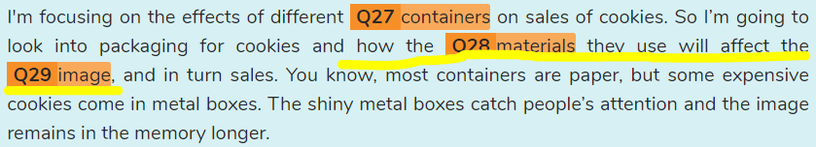

Materials 是单独句子的主语，how materials…affect …

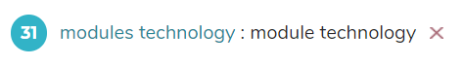

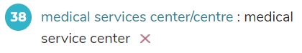

It’s not that necessary to hammer out(敲定)the hours off the bat, especially since it’s easy to come off(得手 脱掉)as lazy when the first thing you bring up is how much you’re going to have to work.

没有必要一开始就敲定时间，特别是当你提出的第一件事是你要工作多少时，很容易让人觉得你很懒惰。

A study?

only if air pollution is fairly mild(温和的 柔和的).

…只有在空气污染相当温和的情况下。

At least one reference needs to be from Q22________

JULIE: Sure. You need to find scientific research that supports your claim as one of your references. It can be from some of the case studies we discussed in class, or you can find your own.

* The keyword concerned in **Q22** must be “**reference**”
* As Ricky asks what is the specific requirements of this paper, Julie points out that Ricky needs to find **scientific research** which is one of his references to support his essay.
* Therefore, a requirement is that at least one reference needs to be from scientific research. For that reason, the answer for **Q22** is **scientific research.**

Q:It mainly refers to **12**  waste.

S:The majority of building waste is paper,

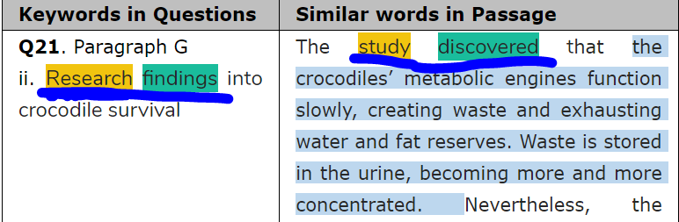

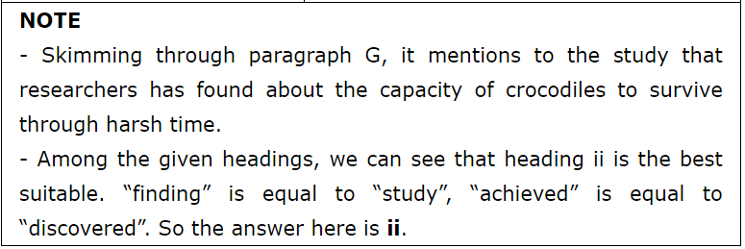

With the help of windmills, farmers used to pump water from wells or turn large grinding stones to grind wheat or corn.

在风车的帮助下，农民曾经从井里抽水或转动大磨盘来磨制小麦或玉米。 Hopper 漏斗

Cages were thus built to withstand storms.

因此，笼子是为了抵御风暴而建造的。

rheumatic pain 风湿性疼痛, breeding 养殖 繁殖 育种,

The draughts(气流) and the variable quality of the wax mainly influenced the time of burning.

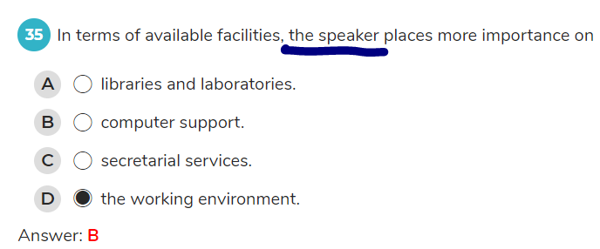

审题 此处对象是the speaker 而非泛指学生

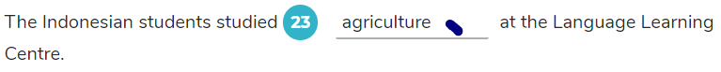

Sometimes we have extra classes for students who have particular courses in mind, and we have just said goodbye to a group of thirty Indonesian students who were preparing for a university course in agriculture. They came to us for English for farming, and they were with us for a long time. We miss them!

审题，___ at the language learning center. 而agriculture 是 将来的大学课程。 所以答案是 English for farming

 I'll be out of here(->leave) in half an hour.

/////

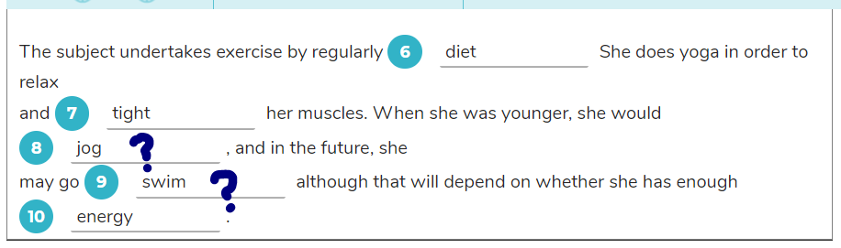

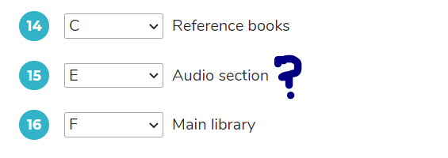

29, 31单数或复数？

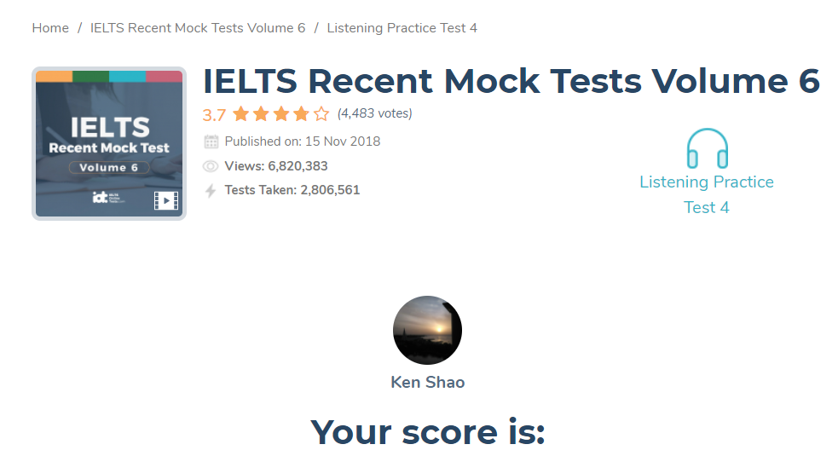

再做又是5.5，明天早上来听几遍吧

Younger -> used to

Q: she may go ___

S: I’m thinking about going **swimming**, at the local aquatic centre, although my husband thinks we should just jog.

我正在考虑去当地的水上运动中心游泳，尽管我丈夫认为我们应该慢跑。(即使丈夫。。。她也考虑游泳)

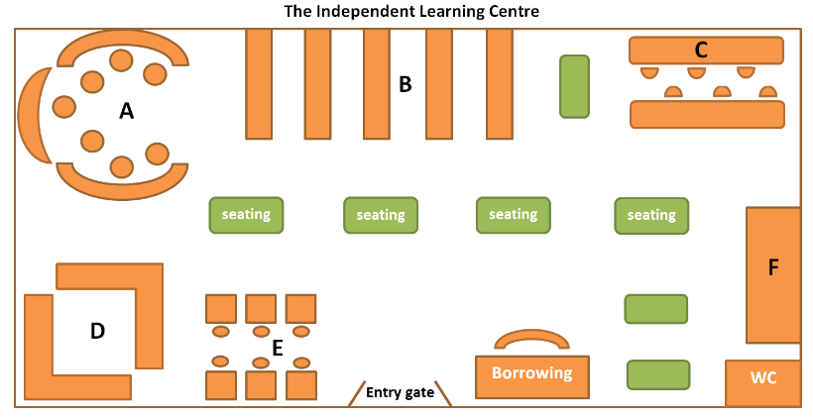

方位题，如果说到了 right beside us, 就要回到出发点，而不是就着图中提到的区域找。

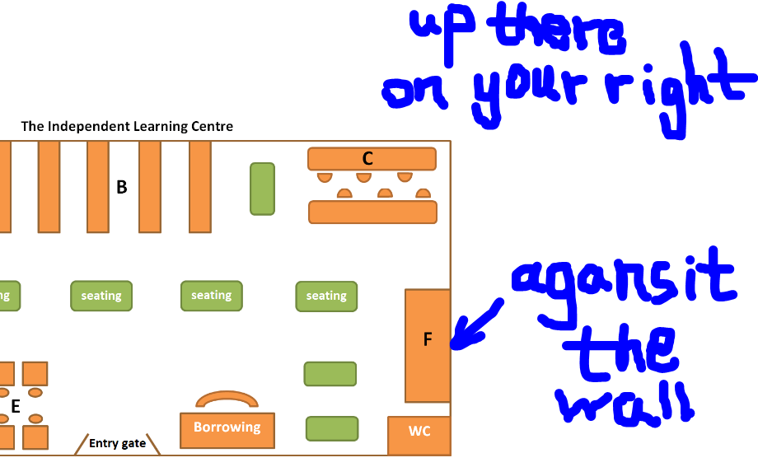

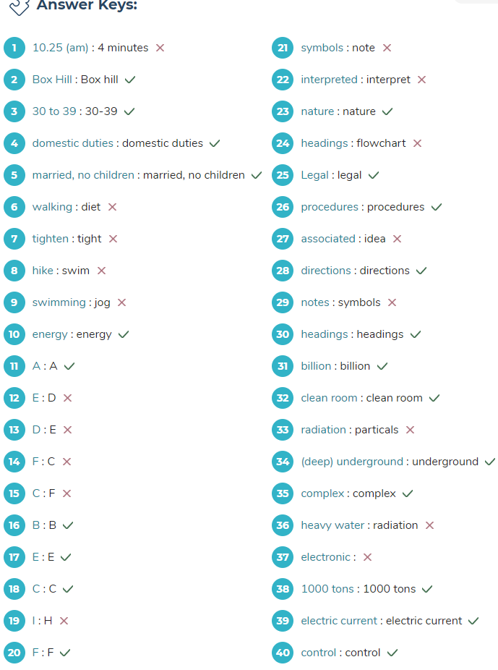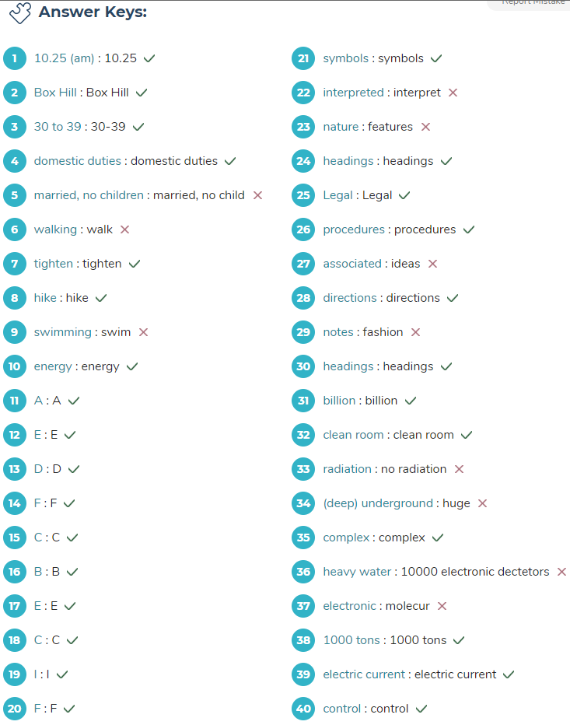

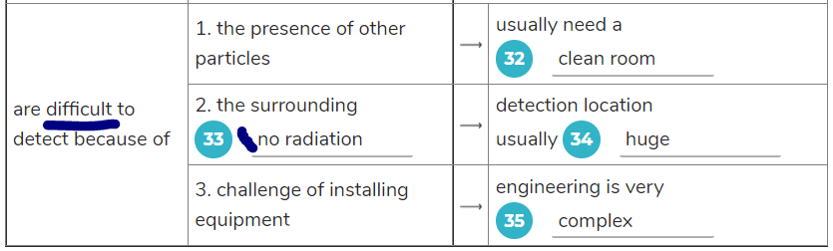

Difficult 后面就不用 no, 审题注意吧。

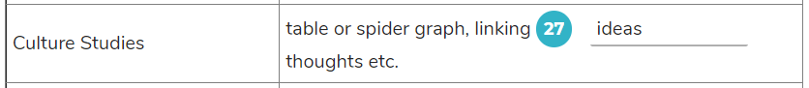Emily: Then use a spider graph—like the web a spider makes, where there’s a central idea around which you attach all the associated thoughts, and ideas, and impressions.

27 正确答案应该是associated

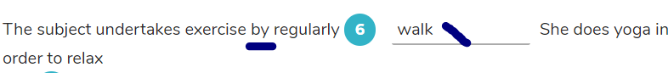

根据语法，这里应该用 walking

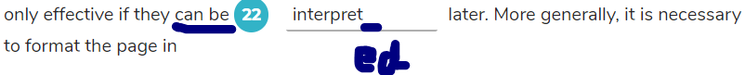

专注审题 被动语态 +ed

17点31分 2022年2月17日

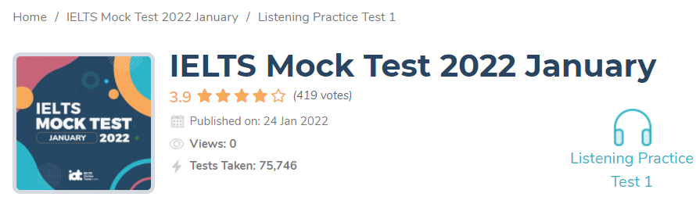

|  |  |
| --- | --- |
| **Keywords in Questions** | **Similar words in Passage** |
| 38.Do exercises for ______ so you may find someone to join you. | You should try to make keeping fit fun ! It’s very hard to go out and do exercise by yourself, so it’s wise to find a sport that you like and do it with other people. |
| The keyword in Q38 is “do exercise”.  By looking at the question, we can guess that the answer here may be a noun because the position after a preposition should be a noun. However, we usually hear that “Do something **for fun**”, “for fun” is a common phrase and “Do exercise for fun” also make sense. Thus, the answer for Q38 is **a noun that we need to look for** or the word “**fun”**.  When we hear the doctor said “You should try to make **keeping fit fun**”. “keep fit” means do exercise. In other words, he meant that people should try to do exercise for fun. So, **fun** is the correct answer. | |

|  |  |
| --- | --- |
| 35.**Environmental factors affecting health:**  air or water pollution  the threat of _______  is most under-rated(被低估的). | We did a smaller survey in which we looked at environmental factors which affect health. I had privately expected to find air or water pollution to be the biggest hazards, and they must not be ignored. However, the effects of the sun emerged(出现) as a threat which people simply do not take sufficiently seriously . (然而，太阳的影响作为一种威胁出现，人们根本没有充分重视。) |

|  |  |
| --- | --- |
| **Keywords in Questions** | **Similar words in Passage** |
| 33. Disturbing findings about men’s health • the group who was at most risk of early death is _______ | Our department has recently completed a survey of men’s health. We looked at men in different age groups and occupations, and we came up with a disturbing insight. Young men , particularly working class men, are at considerable risk of premature death because of their lifestyle |
| From the question, we can assume that the answer is a noun which indicates a group of people.  The keywords in Q33 are “disturbing findings” and “men’s health” and “at most risk of early death”.  When the doctor mentioned to the keywords “men’s health” and “disturbing insight” (which also means disturbing findings) shortly after that, we can be sure that the answer will appear soon.  Then, we hear “Young men …, are at considerable risk of premature death”. We should know that “premature death” means early death. Therefore, the group who was at most risk of early death is young men. The answer is **young men.** | |

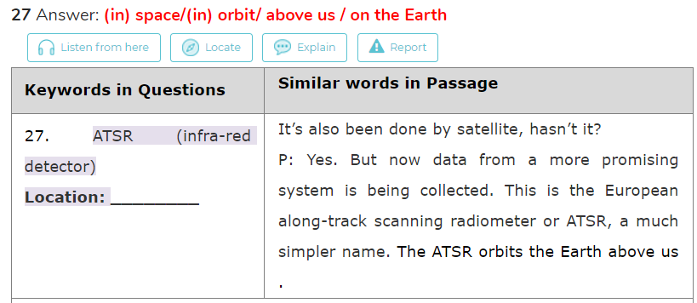

***NO MORE THAN THREE WORDS***

|  |  |
| --- | --- |
| **Keywords in Questions** | **Similar words in Passage** |
| 15. Cause: High rainfall in Queensland  Effect: _________ | Apparently some pieces of raw ginger found their way to an area about 100 kilometres north of Brisbane in Queensland earlier this century. The comparatively high rainfall and humidity in this area produce conditions which are perfect for growing ginger |

正确答案Perfect conditions 注意这里有复数，而我错在了忘记加s

|  |  |
| --- | --- |
| **Keywords in Questions** | **Similar words in Passage** |
| 12. Ginger was first grown in _________ | But first, let's take a brief look at its history before we look at how it can be used, because it has a very interesting history. Ginger originated in the southern provinces of China and in India , where it had been used in medicine and food for over 5,000 years. |
| The keyword in Q12 is “first grown in”.  From the question, we assume that the answer is a noun which indicates a place where ginger was first grown in.  When we hear the woman mentioned the word “its history” in “let's take a brief look at its history “, we can assume that the answer will follow because “first grown in” is an action that took place in the past.Then we hear “Ginger originated in..”. “originated” means first grown in or first come from. So, we know that the answer will appear right after this. And she said that ginger originated in China and India. So the answer is **China, India.** | |

**12** Answer: **China; India (in either order)** 而我错在了只写了China

|  |  |
| --- | --- |
| **Keywords in Questions** | **Similar words in Passage** |
| 13. Spice traders were able to get **_____** for ginger. | Ginger became extremely popular because of its exotic, aromatic properties and was highly valued by spice traders in the 17th and 18th centuries because they were able to sell it back in Europe for a very good price. |
| The keywords in Q13 are “spice traders” and “ginger”.  From the question, we can assume that the answer is a noun which indicates something that spice traders can get from ginger.  When we hear the woman mentioned to the word “traders” in her sentence “The early **traders** who came upon the plant took it to many parts of the world…”, we know that the answer will soon appear.  Then our keyword “spice traders” was mentioned in “**spice traders** in the 17th and 18th centuries…”,so we can be sure that the answer will come out right after it. As we expected, the woman said that spice traders could sell ginger for a very good price. In other words, spice traders can get a good price for selling ginger. So, it is clear that the answer is **a good price.** | |

这道题我没听出来因为没理解长难句

Ginger became extremely popular because of its exotic, aromatic properties and was highly valued by spice traders in the 17th and 18th centuries because they were able to sell it back in Europe for a very good price.

由于生姜具有异国情调和芳香的特性，它在17和18世纪受到香料商人的高度重视，因为他们能够以非常好的价格将其卖回欧洲。

22-25 these?? 是的 24?? 30 conlogical order

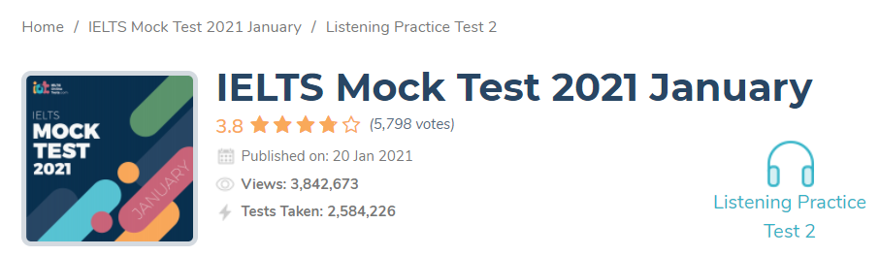

6.5 27/40

|  |  |
| --- | --- |
| **A** | Western Wing |
| **B** | Rear Annex |
| **C** | Matheson Building |

———was damaged in the fire? 答案是 A

An interesting event was the fire which broke out just after the Rear Annex was constructed. It was found that some faulty wiring linked to the main transformer caused the lire, starting in the central building, spreading out to the Medical Library, Western Wing, and the Pediatrics Section. Fortunately, no lives were lost, although the damage bill was considerable. Apart from that, it’s been pretty much plain sailing for the hospital, allowing it to gain the high regard in which it is held today. Now, do you have any questions?

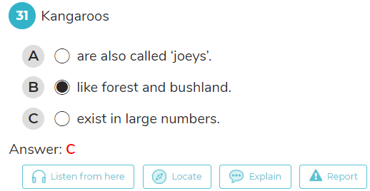

* The **keywords** in **Q31** are **“Kangaroos”**
* Follow the speech, we can hear the lecturer mentioned all of three options, we can **rule our option A and B** as the correct answers because:
* **Option A:** from the text, we can hear “**anil with the baby kangaroo, known as a “joey**”, it **doesn’t mean** “**kangaroos are also called joeys”**
* **Option B**: the lecturer also said “**these animals have been highly favoured by the widespread clearing of forest and bushland in the past**”, it is **not the same** with they **like forest and bushland.**
* **Option C is the correct** answer because “**Ironically.kangaroos breed in such numbers, up to 50 million per year**”, it also means kangaroos **exist in large numbers.**
* Thus, the answer for **Q31** should be “**C**”

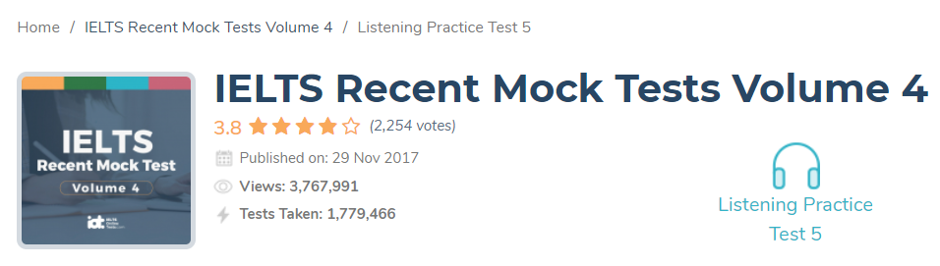

[IELTS Recent Mock Tests Volume 4 Listening Practice Test 5 (ieltsonlinetests.com)](https://ieltsonlinetests.com/22265228/result/ielts-recent-mock-tests-volume-4-listening-practice-test-5)

得分 5.5 20/40 错解6 11 13 16 18 19 24 25 26 27 30 31 33 34 35 36 37 38 39 40

6.When is Mike’s wife’s first appointment?

* **A** Friday 21st at 2.00pm.
* **B** Friday 21st at 2.30pm.
* **C** Friday 21st at 3.30pm.

原文R: There are appointments available at 2.00, 2.30 and 3.30. M We’ll take the first one please.

11 原文 fee of 5 pounds, 答案 5 pounds fee(不超过3词)

13 本不难，由于受11的影响而没跟上。

16 正解1 week  错答1 week per book, 不超过3词

18 正解non-lending(section) : 错答non-lending sections

19 原文On the first floor above us, we have the **Arts section**, which includes books that students will need for such as ]as languages, literature, art and history.

Art 美术 arts 文科

24 对e-mail attachment : 错email as attachment

原文You could do that but I’d prefer it if you just **e-mailed it to me as an attachment**.

(***NO MORE THAN THREE WORDS AND/OR A NUMBER***)

25 I want to look into how supermarkets use market surveys to develop their products.

|  |  |
| --- | --- |
| **Keywords in Questions** | **Similar words in Passage** |
| **Q25:**  Jennifer wants to write about how [______] are used by supermarkets. | Tutor: OK, what are you writing about then?  Jennifer: I want to look into how supermarkets use **market survey** to develop their products. |

|  |  |
| --- | --- |
| **Keywords in Questions** | **Similar words in Passage** |
| **Q26:**  Jennifer found some publications in the library Q26 [______] to help her analysis. | Jennifer: I should be OK. I’ve had a look in the **stack system** in the library and I’ve found a magazine that surveyed all the UK major supermarkets and a trade publication that analysed the same things in Canadian supermarkets. |

|  |  |
| --- | --- |
| **Keywords in Questions** | **Similar words in Passage** |
| **Q27:**  The tutor warned Jennifer about [______] in her work. | Tutor: Be careful about *using their conclusions too much*. The university takes a tough stance on **plagiarism**. Make sure you properly list where you get your information from in a bibliography and try and do your own analysis. Get going too as that analysis will take a bit of time. |

|  |  |
| --- | --- |
| **Keywords in Questions** | **Similar words in Passage** |
| **Q30:** She’s going to write about Q30 [______] in the UK and their effect on housing trends. | Melanie: I thought I’d do an overview of the UK **mortgage interest rates** and their effect on housing sales trends over the last 10 years. I thought it might be of interest because of the huge increases of house prices over the last decade. |

# SECTION 4(10题只对了1题)

Good afternoon and welcome to this Earth Sciences lecture. Today we’re going to look at tidal ; or more correctly, tsunami .  
  
Deep below the ocean’s surface tectonic plates collide, and every once in a while, these forces produce an earthquake . The energy of such submarine earthquakes(海底地震) can produce tidal waves, which radiate out in all directions from the epicentre of the quake, moving at speeds of up to 500 miles per hour. When these waves reach shore, they can cause enormous destruction and loss of life. Tidal waves are actually miss named . They are not caused by tides. A more accurate word for them is the Japanese name tsunami, which means, harbour wave. They are also sometimes called seismic(地震的) sea waves, since they can be caused by seismic disturbances such as submarine quakes. However, that name is not really accurate either, since tsunami can also be caused by landslides(山体滑坡) , volcanic eruptions , nuclear explosions, and even impacts of objects from outer space, such as meteorites(陨石) , asteroids, and comets .

Earthquakes though are the largest cause of tsunami. Tectonic plates cover the world’s surface and their movement can be detected anywhere in the world. Some areas of the world are more prone to greater movement, and it is in these places that the largest waves can occur. Large vertical movements of the earth’s crust occur at plate boundaries which are known as faults. The Pacific Ocean’s denser oceanic plates are often known to slip under continental plates in a process known as subduction , and subduction earthquakes are the most effective in generating tsunamis.

A tsunami can be generated by any disturbance that displaces a large water mass from its equilibrium position. In the case of earthquake-generated tsunamis, the water column is disturbed by the uplift or subsidence of the sea floor. Submarine landslides, which often accompany large earthquakes, as well as collapses of volcanic edifices, can also disturb the overlying water column as sediment and rock slump down, and are redistributed across the sea floor. submarine volcanic eruptions can create an impulsive force that uplifts the water column and generates a tsunami. Conversely, super marine landslides and cosmic body impacts disturb the water from above, as momentum from falling debris is transferred to the water into which the debris falls. Generally speaking, tsunamis generated from these mechanisms , unlike the devastating Pacific-wide tsunamis caused by earthquakes, dissipate quickly and rarely affect coastlines distant from the source area.  
  
Tsunamis are very hard to detect, since they cannot be seen when they are in the deep ocean.  
  
The distance between two wave crests can be 500 kilometers and, because of this, the wave height is only a few feet. Because the rate at which a wave loses its energy is inversely related to its wavelength , tsunamis not only propagate at high speeds, they can also travel great, transoceanic distances with limited energy losses. As the tsunami reaches shallow water however, its speed decreases, but the energy it contains remains about the same. Instead of travelling fast, the wave rises high.  
  
The National Oceanic and Atmospheric Administration has set up a seismic detection system to monitor earthquakes and predict the possible arrival of tidal waves for Pacific countries. Buoys at sea can also detect water pressure changes that can indicate tsunamis moving through the ocean. But when tsunamis originate near the shore there is often little chance to warn people.  
  
Let’s look at some examples of tsunami and their causes and effects

Some can be relatively harmless. In 1992 an offshore landslide caused a tidal wave of only about three feet high that struck at low tide, so Humboldt County, where it hit, got off easy with no casualties .  
  
On January 13th in 1992, a Pacific Ocean earthquake off the coast of San salvador , registering 7.6 on the Richter scale, did not cause any ocean disturbance at all.  
  
However, a recent tidal wave, which struck Papua New Guinea on july 17th 1998 , was 23 feet high, and killed at least 1200 people. This wave was caused by a magnitude 7.1 submarine earthquake.  
  
On July 17, 1998 a Papua New Guinea tsunami killed roughly 3,000 people A huge underwater volcanic eruption 15 miles offshore was followed within 10 minutes by a wave some 40 feet tall. The villages of Arop and Warapu were destroyed.  
  
One of the worst tsunami disasters engulfed whole villages along Sanriku, Japan, in 1896 . An underwater earthquake induced a wave of 35 feet drowning some 26,000 people.  
  
Finally, about 8,000 years ago, a massive undersea landslide off the coast of Norway sent a 30- foot wall of water barreling into the uninhabited northern coast of Europe. If this were to recur today, as scientists say it could, almost anywhere in the world, it would cost billions if not tens of billions of dollars to repair the damage to coastal cities and kill tens of thousands of people.

|  |  |
| --- | --- |
| **Q33:** Tsunami are difficult to detect in deep water because of…  A. their wavelength.  B. their high speed.  C. their wave rate. | Tsunamis are very hard to detect, since they cannot be seen when they are in the deep ocean.    **The distance between two wave crests** can be 500 kilometers and, because of this, the wave height is only a few feet.  Because the rate at which a wave loses its energy is inversely related to its wavelength , tsunamis not only propagate at high speeds, they can also travel great, transoceanic distances with limited energy losses. |
| **Note**:  First of all we learn that tsunamis are difficult to detect in the deep ocean because they cannot be seen. Why can't they be seen? Because the wave height is only a few feet. Why the wave height is so low? Because the distance between two wave crests can be 500Km. The distance between two wave crest is the definition of **wavelength**.  Note that while the next sentence contains the keyword "wavelength", it goes on about energy, speed, etc and has nothing to do with explain how tsunamis are difficult to detect in deepwater.  Hence the answer for this question is **A. their wavelength**. | |

|  |  |
| --- | --- |
| **Q40:**  When Happened: 8000 years ago  Cause: Underwater landslide  Deaths caused: [______]  Wave height: 30 feet | Finally, about 8,000 years ago, a massive undersea landslide off the coast of Norway sent a 30- foot wall of water barreling into the **uninhabited** northern coast of Europe. |
| **Note**: Since the coast is **uninhabited**, there is no death. However, we should put in **none** as the answer as is the case for the first two rows in the table.  The answer for Q40 is "**none**" | |